ARDUINO

COMPONENTS OF basics Arduino:

## 1-[ATmega328P](https://content.arduino.cc/assets/Atmel-7810-Automotive-Microcontrollers-ATmega328P_Datasheet.pdf?) : Microcontrollers

2- USB power supply: Responsible for transferring code and power from the computer

3- I/O pins: The sensors will be connected to it

4-Power pins: We will take energy from it (it is the one that supplies Arduino energy) and prepare energy for lighting

5-Resat Button: It won't start again Arduino

6-USB Serial: It will transfer data from USB TO Arduino & will receive information from the computer

7-DCpower supply:

8-On led: I keep working, meaning I have an Arduino with power

9-Transferring & Receiving leds: It is divided into 3 LEDs.

1-L: If it works, it indicates that the Arduino is working properly

2- FX: When data is transferred from the Arduino, a red light appears

3-TX, when data is transferred to the Arduino, a red light appears

TYPES OF Arduino:

#### 1- Arduino Uno (R3)

The Uno is a huge option for your initial Arduino. This Arduino board depends on an ATmega328P based microcontroller. As compared with other types of arduino boards, it is very simple to use like the Arduino Mega type board. .It consists of 14-digital I/O pins, where 6-pins can be used as PWM([pulse width modulation](https://www.elprocus.com/pulse-width-modulation-pwm/) outputs), 6-analog inputs, a reset button, a power jack, a USB connection, an In-Circuit Serial Programming header (ICSP), etc. It includes everything required to hold up the microcontroller; simply attach it to a PC with the help of a USB cable and give the supply to get started with an AC-to-DC adapter or battery.

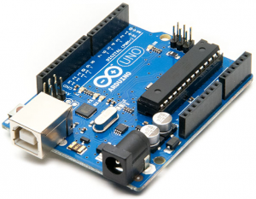

Price: 408EGP

#### 2- Arduino Nano

This is a small board based on the microcontrollers like ATmega328P otherwise ATmega628 but the connection of this board is the same as to the Arduino UNO board. This kind of microcontroller board is very small in size, sustainable, flexible, and reliable.

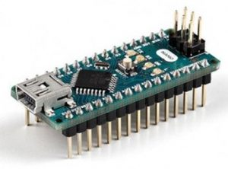

Price:130EGP

#### Arduino Micro

The Arduino Micro board mainly depends on the ATmega32U4 based Microcontroller that includes 20-sets of pins where the 7-pins are PWM pins, 12-analog input pins. This board includes different components like an ICSP header, RST button, small USB connection, crystal oscillator-16MHz. The USB connection is inbuilt and this board is the shrunk version of the Leonardo board.

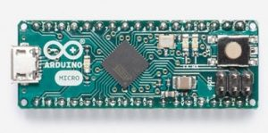

Price: 145EGP

## 4- What is an Arduino Mega 2560

The microcontroller board like “Arduino Mega” depends on the ATmega2560 microcontroller. It includes digital input/output pins-54, where 16 pins are analog inputs, 14 are used like PWM outputs hardware serial ports ([UARTs](https://www.elprocus.com/basics-of-uart-communication-block-diagram-applications/)) – 4, a [crystal oscillator](https://www.elprocus.com/crystal-oscillator-circuit-and-working/)-16 MHz, an ICSP header, a power jack, a USB connection, as well as an RST button. This board mainly includes everything which is essential for supporting the microcontroller. So, the power supply of this board can be done by connecting it to a PC using a USB cable, or battery or an AC-DC adapter. This board can be protected from the unexpected electrical discharge by placing a base plate.

Price:500

Comperions between Arduino uno & Arduino mega:

